Chapter 6 – Counting Techniques

And Chapter 6 Popper

6.1 The Multiplication Principle or the Fundamental Counting Principle

Remember tree diagrams? How does mutually exclusive fit into tree diagrams? Let’s discuss the information at the tip of the tree diagram.
If our student has 3 pairs of school pants and 5 school shirts and 2 pairs of shoes or sneakers, how many outfits can he make?

This process is the way to use the Fundamental Counting Principle.
Chapter 6 Essay 1
Write a brief one page discussion of the Fundamental Counting Principle in your own words using the definition in the book or online as a cited source.
Chapter 6 Popper Question 1
If a menu has 4 entrees, 3 side dishes, and 6 desserts, how many meals can be ordered?
A. 4 + 3 + 6 = 13
B. 4(3)(6) = 72

Now let’s look at Venn Diagrams:
This is just another way to organize information into mutually exclusive sets that are arranged visually
Two set Venn diagrams and three set Venn diagrams are discussed here.
The usual Venn diagrams might be helpful here:

Let’s discuss the parts, unions and intersections of these two sets.
The circle on the left is A and the one on the right is B; the box containing the circles is the Sample Space or the Universe.
Find A∩B, AUB, only A, neither A nor B

Translate A∩B into words…what is the key word?
Translate AUB into words…what is the key word?

Chapter 6 Popper Question 2
A two set Venn diagram can be broken down into 4 disjoint subsets.
A. True B. False
Venn Diagram Problem 1 together
From a survey of 100 college students, a marketing research company found that 75 students owned Ipods, 45 owned cars, and 35 owned Ipods and cars.
How many students owned either a car or an Ipod?
How many student owned neither?
Which parts or which and how many students in each part! What are the parts called?

Chapter 6 Popper Question 3
A common error with two set Venn diagrams is double counting the intersection.
A. True B. False

Chapter 6 homework problem 1
A survey of 64 informed voters revealed the following information:
45 believe that Elvis is alive
49 believe that they have been abducted by aliens
42 believe both of these things
How many people believe neither?
How many believe Elvis is alive but don’t believe that they’ve been abducted by aliens?

Chapter 6 Popper Question 4
There’s a typo in the homework question above. It wasn’t 64 informed voters in the survey; it was 45 + 49 + 42 = 136 people in the survey.
A. True B. False

Three set Venn diagrams:

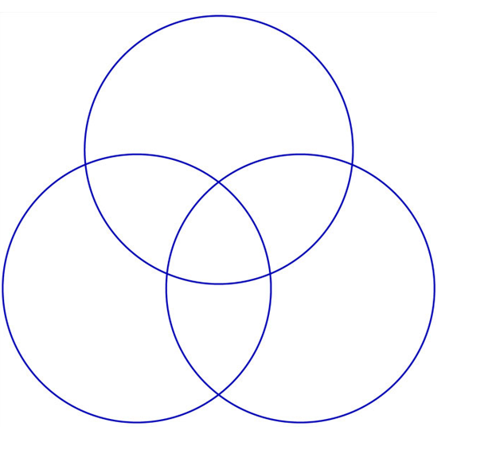

Let’s discuss parts!
Chapter 6 Popper question 5
A 3 set Venn Diagram has 8 disjoint parts.
A. True B. False
VD Problem 3
A survey of Math faculty at UH revealed the following:
51 admire Moe
49 admire Larry
60 admire Curley
34 admire Moe and Larry
32 admire Larry and Curley
24 admire all three Stooges
12 admire only Moe
1 dislikes all 3

How many people are there in the Math department?
How many admire Curly but not Larry and not Moe?
How many admire Larry or Curley?
How many admire just one Stooge?
How many admire exactly 2 Stooges?

6.2 Permutations
Who remembers the permutations formula? (see page 165 for a reminder!)
Permutations are a fraction. The permutation of n things taken r at a time is:
n! (n factorial) in the numerator and (n-r)! (n minus r)factorial in the denominator.

What is important about permutations?

The calculator instructions are on page 162 in the book

With replacement and without replacement – BOY does it matter! Page 163
The first half of this section is without replacement. With replacement starts on page 167 (we’ll get there next).

Check out with replacement…the sample space stays the same. Without replacement the sample space decrements by r each time the experiment is performed.

6.3 Combinations page 168

Formula: page 171

The combination of n things taken r at a time.

Numerator: n! The same.

Denominator: r!(n-r)! An extra divisor making fewer Cs than Ps.

What’s important about combinations?

Calculator: page 171 and 172

Check out the Focus on Understanding on page 172; it’s well done.

Chapter 6 Popper Question 6

The Permutation and Combination formulas are alarmingly alike. If it weren’t for the r! divisor in the PERMUTATION formula they’d be identical.

A. True B. False

Hint, trick question, read it carefully!

Chapter 6 Homework Problem 2
Answer the Dr. Math question on page 173 plus write the answers to theFocus on Understanding questions 1 and 2, p. 172

6.4 Mixed Counting Problems

Let’s go through each question and discuss WHY the choice of how to solve it is correct and how we would know we were right if the book hadn’t spelled out the answer! For the test: no computation, just circling the right word!

Permutations and Combinations – a quick review + problems
Quick review:
Permutations are the number of possible arrangements when order matters.
A permutation of n objects taken r at a time is computed using
So your answer is a number of outcomes.
A permutation of 11 objects taken 4 at a time is calculated:
which is 7,920.

Combinations are the number of possible arrangements when order does NOT matter. A combination of n objects taken r at a time is computed using

Again, your answer is a number of outcomes that you will use in a probability ratio.

A combination of 11 objects taken 4 at a time is calculated

which is 330.

Note that there are far fewer combinations than permutations? 330 vs 7,920. That’s the effect of that extra divisor: r!

Chapter 6 Essay 2
Discuss briefly WHY r! makes such a difference between the two formulas.

P&C Problem 1 together

How many 8-letter permutations can be formed from the letters in the word “hesitate”?
Zero factorial: 0! = 1 by convention

P&C Problem 2
Find the number of different lines determined by 11 points, no three of which lie on the same line.

P&C Problem 3
From a group of 12 students, in how many ways can a 6 person team be formed?

P&C Problem 5
Find the number of ways of arranging the letters in the word “object”.
P&C Problem 5 (foreshadowing the test).

Would you use a permutation or a combination to solve the following problems:

A. the number of ways a 5 card hand can be dealt from a 52 card deck

B. making 3 digit numbers from the digits {1, 2, 3, 4, 5}

Chapter 6 Summary

Chapter 6 Popper Questions: 6 of these

Essays: 2 of these

Homework in script: two plus from text: 2, 6, 8, 12

Next up Test 1 and after that see you in Chapter 7!

Then Test 2 on Chapter 7

Then 3 more chapters and the final.

